BLE4.2

Transparent Transmission Module Data Sheets

**UA287Q-BLE**

V1.2

2018.02.26

Shenzhen JIXIAN Technology Co., Ltd.

T:0755-82571152 F:0755-88373753

<http://www.uascent.com>

4F, Building A, Tongfang Information Harbor,  No.11, Langshan Road, North Area of High-tech Park, Nanshan District, Shenzhen

**CONTENTS**

1. Version History, Disclaimer and Notice 3

1.1 Version History 3

1.2 Disclaimer and Notice 3

2. General Description 3

3. Package and Dimensions 3

4. Schematic and 5V-3V Level Shift Reference Design 4

5. Product Function and Test Description 5

6. UUID 6

7. Communication Interface for Module and MCU 6

7.1 Asynchronous Serial Communication 6

7.2 Packet Format 6

7.3 Operation Mode Setting 6

8. Pin Assignment 6

9. AT Command 7

9.1 AT Command List 7

9.2 Set Baud Rate 7

9.3 Read BLE Name 8

Replies: “AT+ok\r\n” (Operation completed); “AT+err_code\r\n” (Operation failed, refers to“Returned error code indication”for detailed err_code) 8

9.4 Set BLE Device Name 8

9.5 Read BLE MAC Address 8

9.6 Set BLE MAC Address 8

9.7 Read BLE Status: Broadcast/Connected/Sleep 8

9.8 Set Broadcast Interval 8

9.9 Set Connection Interval 8

9.10 Disconnect BLE 9

9.11 Reset/Restart 9

9.12 Read Parameter 9

9.13 Exit Command Mode 9

9.14 Shut Down 9

9.15 Factory reset 9

9.16 Version inquiry 9

9.17 Instruction help 9

9.18 Returned Error Code Indication 10

10. Power consumption 10

11. Appendix: Reference Specification 10

# Version History, Disclaimer and Notice

## 1.1 Version History

|  |  |  |  |
| --- | --- | --- | --- |
| Version | Date | Author | Description |
| V1.0 | 2018/2/6 | Water Chen | First draft |
| V1.1 | 2018/2/16 | Water Chen | updated |
| V1.2 | 2018/2/26 | Water Chen | updated |

## 1.2 Disclaimer and Notice

The document is provided “AS IS”, without warranty of any kinds, including the implied warranties of merchantability and applies to any guarantee for a particular purpose, or non infringement, and any proposal, specification or sample of any guarantee mentioned anywhere else.

This document does not bear any responsibility, including the use of the document information from infringement of any patent infringement liability.

This document is not here by estoppel or otherwise, any intellectual property rights is granted the license, whether express or implied license.

The information in this document might be modified for upgrade or other reasons. JIXIAN corporation reserves the rights to make change without notice. This document is used for design guide only, JIXIAN corporation try the best to supply the correct information, but it does not assure there is not any error in this document. All the ostensive or implied states, information, suggestion are not guaranteed.

# General Description

Module UA287Q is based on high-performance SOC which highly integrated with Bluetooth 4.2 low energy single mode processor. It integrates a high-performance 2.4GHz RF transceiver, rich features baseband, ARM968E-S MCU and various peripheral IOs. It has embeded 4Mbit FLASH and 64KByte RAM to enable programmable protocol and profile to support customized applications.

# Package and Dimensions

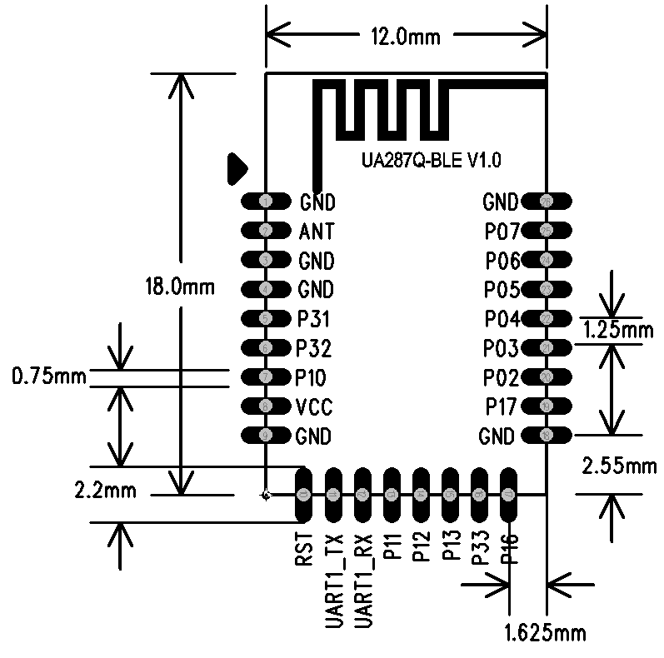

# Schematic and 5V-3V Level Shift Reference Design

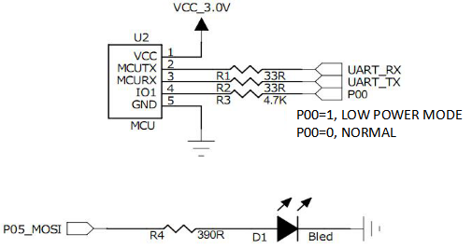

**Schematic**

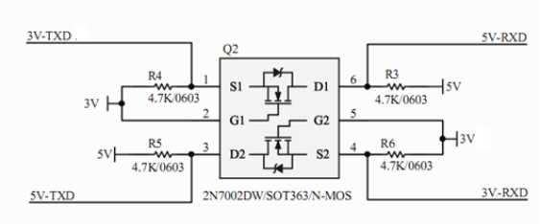

**5V-3V Level Shift Circuit 1**

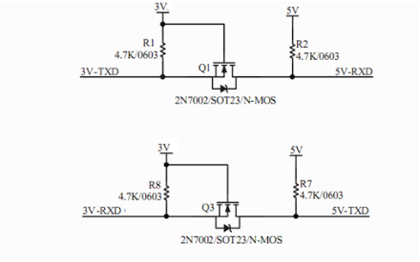

**5V-3V Level Shift Circuit 2**

# Product Function and Test Description

BLE slave mode support.

●Default setting:

Operation Mode: transparent transmission mode default. For using the AT command please switch to the command mode;

UART parameter: 9600, 8 bit data, no parity bit , 1 bit for stop;

BLE name: BleSerialPort;

Broadcast interval: “80, 80”, max=50ms, min=50ms;

Connect interval: “36,24,2,100”, max=36, min=24, latency=2, timeout=300(max=45ms,min=30ms,latency=2,timeout=1000ms).

●UART ports could be enabled to switch operation status and sleeping status.

●AT command mode and transparent transmission mode could be swithed by using command.

●AT command for parameter configuration is available.

●At 0dBm Tx power, connecting distance reaches 40m in open area.

●Each frame can packet up to 20 bytes data.

●Sleeping current: refer to chapter 10

●Supply voltage: 1.55~3.5V, 3.0 V is recommended

●Dimension: 18mm*12mm*1.7mm

●Applications:

BLE health products, Wearable devices, Smart home, BLE toys, Lighting control, Bluetooth to serial products.

# UUID

Slave service UUID: 0xFFB0

Eigenvalue UUID: 0xFFB1 Properties: Write Notify

Eigenvalue UUID: 0xFFB2 Properties: Write Notify

# Communication Interface for Module and MCU

## 7.1 Asynchronous Serial Communication

BLE module communicate with MCU by serial port (UART).

Default port parameter: baud rate 9600, 8 data, 1 stop, no parity.

## 7.2 Packet Format

Transparent transmission mode: BLE module forwards the data from MCU to APP without change. And the same as data from APP to MCU.

Instruction mode: Module can be configured by AT command by either APP or PC UART.

## 7.3 Operation Mode Setting

Switching between AT command mode and transparent transmission mode:

Power on default transparent transmission mode. Send“+++” then return“AT+ok Mode=AT Mode\r\n”, the module turns into AT command mode and AT command are available for setting and reading.

Send“AT+exit\r\n”then return“AT+ok Mode=Normal\r\n”, the module turns back to transparent transmission mode and data will be transparently transmitted directly.

**Notie:** **Don’t insert any other characters inside “+++”.**

# Pin Assignment

|  |  |  |  |  |  |
| --- | --- | --- | --- | --- | --- |
| 1 | GND | PWR GND | 14 | P12 | General IO/ PWM2 |
| 2 | ANT | Antenna port | 15 | P13 | General IO/ PWM3 |
| 3 | GND | GND | 16 | P33 | General IO/ ADC3 |
| 4 | GND | GND | 17 | P16 | General IO/ UART2_TX |
| 5 | P31 | General IO/ ADC1 | 18 | GND | GND |
| 6 | P32 | General IO/ ADC2 | 19 | P17 | General IO/ UART2_RX |
| 7 | P10 | General IO/ PWM0 | 20 | P02 | General IO/ I2C_SCL |
| 8 | VCC | POWER | 21 | P03 | General IO/ I2C_SDA |
| 9 | GND | GND | 22 | P04 | General IO/ SPI_SCK |
| 10 | RSTN | Analog(Active low pin reset) | 23 | P05 | General IO/ SPI_MOSI |
| 11 | P00 | GND/ UART1_TX | 24 | P06 | General IO/ SPI_MISO |
| 12 | P01 | General IO/UART1_RX | 25 | P07 | General IO/ SPI_NSS |
| 13 | P11 | General IO/ PWM1 | 26 | GND | GND |

UART switch: 24PIN(P06). UART enabled at low level and module stays in normal mode. UART closed at low level and module enters low power mode.

Status lamp: 14PIN(P12). Low level while disconnected and get high while connected. Or high level when receiving data from APP and low level that after.

On&off：14PIN(P13), low for DEEPSLEEP mode, high for normal mode,hanging for work mode.

# AT Command

Notice: Power on default transparent transmission mode, and send“+++” into command mode. AT command finishes with “\r\n” in command mode. Tick ”send new line” in serial port assistant.

## 9.1 AT Command List

|  |  |
| --- | --- |
| Command | Description |
| “AT+setBR 9600\r\n” | Set baud rate |
| “AT+getName\r\n” | Read BLE name |
| “AT+setName=bleName\r\n” | Set BLE name |
| “AT+getAddr\r\n” | Get BLE address |
| “AT+setAddr=112233445566\r\n” | Set BLE address |
| “AT+getStatus\r\n” | Get BLE status |
| “AT+setAdvInt 80 100\r\n” | Set broadcast interval |
| “AT+setConnInt 36 24 2 300 \r\n ” | Set connection interval |
| “AT+disConnect\r\n” | Disconnect |
| “AT+reStart\r\n” | Restart |
| “AT+getPara\r\n” | Get config parameter |
| “AT+exit\r\n” | Exit command mode(truns to transparent transmission mode);  Send “+++”swichs to command mode to transparent transmission mode. |
| “AT+shutDown\r\n” | Shut down |
| “AT+reStore\r\n” | Factory reset |
| “AT+getInfo\r\n” | Version inquiry |
| “AT+help\r\n” | Instruction help |

## 9.2 Set Baud Rate

Notice: Not valid until manual restart.

Example: “AT+setBR 9600\r\n” (“\r\n”is end mark, hexadecimal as “0D 0A” , the same below)

Hex: 41 54 2B 20 73 65 74 42 52 20 39 36 30 30 0D 0A (There is no space between each number. The space can be inserted by some software and some can ignore spaces automatically, the same below)

Replies: “AT+ok\r\n” (Operation completed); “AT+err_code\r\n” (Operation failed, refer to“Returned error code indication”for detailed err_code)

|  |
| --- |
| Baud rate range: (Error indicated for incorrect baud rate ) |
| 2400, 4800, 9600, 19200, 38400, 57600, 115200 |

## 9.3 Read BLE Name

Example: “AT+getName\r\n”

Hex: 41 54 2B 20 67 65 74 4E 61 6D 65 0D 0A

## Replies: “AT+ok\r\n” (Operation completed); “AT+err_code\r\n” (Operation failed, refers to“Returned error code indication”for detailed err_code)

## 9.4 Set BLE Device Name

Notice: Not availble until manual restart.

Example: “AT+setName=bleName\r\n”(such as SENSSUN FAT)

Hex: 41 54 2B 20 73 65 74 4E 61 6D 65 20 3D 62 6C 65 4E 61 6D 65 0D 0A

Replies: “AT+ok restart effect!\r\n” (Operation completed, valid after sending command and restart); “AT+err_code\r\n” (Operation failed, refer to“Returned error code indication”for detailed err_code)

## 9.5 Read BLE MAC Address

Example: “AT+getAddr\r\n”

Hex: 41 54 2B 20 67 65 74 41 64 64 72 0D 0A

Replies: “AT+ok FF:11:22:33:66:FF\r\n” (Operation completed); “AT+err_code\r\n” (Operation failed, refer to“Returned error code indication”for detailed err_code)

## 9.6 Set BLE MAC Address

Example: “AT+setAddr=112233445566\r\n”

Hex: 41 54 2B 20 73 65 74 41 64 64 72 3D 31 31 32 32 33 33 34 34 35 35 36 36 0D 0A

Replies: “AT+ok restart effect!\r\n” (Operation completed, valid after sending command and restart); “AT+err_code\r\n” (Operation failed, refer to“Returned error code indication”for detailed err_code)

## 9.7 Read BLE Status: Broadcast/Connected

Example: “AT+getStatus\r\n”

Hex: 41 54 2B 20 67 65 74 53 74 61 74 75 73 0D 0A

Replies: “AT+ok status_code\r\n”(Operation completed), status_code as below:

|  |  |
| --- | --- |
| 00 | Idle |
| 01 | Broadcasting |
| 02 | Connecting |
| 03 | Scan with response |
| 04 | scan without response |

“AT+err_code\r\n” (Operation failed, refer to“Returned error code indication”for detailed err_code)

## 9.8 Set Broadcast Interval

Not valid until manual restart.

Example: “AT+setAdvInt 80 100\r\n” (min interval 80*0.625ms, max interval 100*0.625ms)

Hex: 41 54 2B 20 73 65 74 41 64 76 49 6E 74 20 38 30 20 31 30 30 0D 0A

(Maximum and minimum of broadcast interval,“min<=max”, 80~16000 correspond to 50ms~10000ms)

Replies: “AT+ok restart effect!\r\n” (Operation completed, valid after sending command and restart); “AT+err_code\r\n” (Operation failed, refer to“Returned error code indication”for detailed err_code)

## 9.9 Set Connection Interval

Notice: valid immediately, constantly setting will get dropped.

Example: “AT+setConnInt 36 24 2 300 \r\n ”(The value respectively max, min, latency, timeout)

Hex: 41 54 2B 20 73 65 74 43 6F 6E 6E 49 6E 74 20 33 36 20 32 34 20 32 20 33 30 30 0D 0A

In the example above, max interval 36*1.25ms, min interval 24*1.25ms, latency 2, connecting timeout 300*10ms.

Min and max broadcast interval range: 0x0006~0x0C80(7.5ms~4000ms), min<=max.

Latency: value range: 0x0000~0x01F3(0~499).

Connecting time out: value range: 0x000A~0x0C80. Connection interval must less than connecting timeout: [max*1.25 * (1+latency)] < 10 * timeout.

Replies: “AT+ok\r\n” (Operation completed, valid immediately without restart); “AT+err_code\r\n” (Operation failed, refer to“Returned error code indication”for detailed err_code)

## 9.10 Disconnect BLE

Example: “AT+disConnect\r\n”

Hex: 41 54 2B 20 64 69 73 43 6F 6E 6E 65 63 74 0D 0A

Replies: “AT+ok\r\n” (Operation completed); “AT+err_code\r\n” (Operation failed, refer to“Returned error code indication”for detailed err_code)

## 9.11 Reset/Restart

Example: “AT+reStart\r\n”

Hex: 41 54 2B 20 72 65 53 74 61 72 74 0D 0A

Reply: “AT+ok restart now \r\n” (Operation completed, restart at once automatically)

## 9.12 Read Parameter

Example: “AT+getPara\r\n”

Hex: 41 54 2B 20 67 65 74 50 61 72 61 0D 0A

Reply: “AT+ok uart 9600,8,N,1; adv 120 160; con 36,24,2,300.\r\n” (Operation completed), returned parameter contains UART port, broadcast interval, connection interval.

## 9.13 Exit Command Mode

Example: “AT+exit\r\n”

Hex: 41 54 2B 20 65 78 69 74 0D 0A

Reply: “AT+ok Mode=Normal\r\n” (Operation completed, switches to transparent transmission mode)

## 9.14 Shut Down

Example: “AT+shutDown\r\n”

Hex: 41 54 2B 20 73 68 75 74 44 6F 77 6E 0D 0A

Reply: “AT+ok power off now!\r\n”(Operation completed)

## 9.15 Factory reset

Example:“AT+reStore\r\n”

Hex: 41 54 2B 20 72 65 53 74 6F 72 65 0D 0A

Reply:“AT+ ok restart now\r\n”(Operation completed)

## 9.16 Version inquiry

Example:“AT+getInfo\r\n”

Hex: 41 54 2B 67 65 74 49 6E 66 6F 0D 0A

Reply:AT+ok HW=UA287Q-BLE-JXKJ,SW=V0.2

## 9.17 Instruction help

Example: “AT+help\r\n”

Hex:41 54 2B 20 68 65 6C 70 0D 0A

Reply:AT+ok Help:

system_shutdown

setBR

getName

setName

getAddr

setAddr

getStatus

setAdvInt

setConnInt

disConnect

reStore

reStart

getPara

getInfo

exit

help

## 9.18 Returned Error Code Indication

|  |  |
| --- | --- |
| err_code | Indication |
| “06” | The last operation was not completed |
| “07” | Command parameter is not valid |
| “08” | Disconnected |
| “09” | Connecting |
| “10” | Broadcasting |
| “11” | Operation failed |

# Power consumption

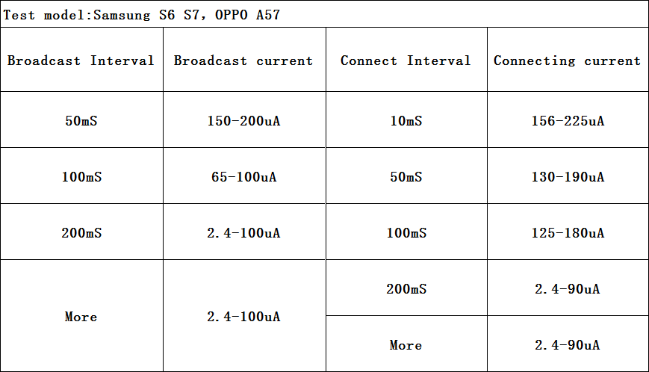

# Appendix: Reference Specification

《BLUETOOTH SPECIFICATION Version 4.2》

《IEEE 802.15.1》